** **

**SUMMER SCHOOL OF OSTEOLOGY AND ANTROPOLOGY, PONTESTURA (AL)**  
**Università degli Studi di Milano**

**13 - 18 July 2020**

**REGISTRATION FORM**

**Deadline 6 June 2020**

**First name**: _______________________________ **Last name**: ____________________________________  
**Fiscal Code (for Italian students)_______________________________________________________**  
**Address**: _____________________ **City**: _______________ **Postal code**: __________  
**Home phone**: ____________________ **Mobile phone:**__________________

**E-mail**: ______________________  
□ Student of the University of Milan, Bachelor or Master of Natural Sciences   
□ Student of the University of Milan, Bachelor of Science in Cultural Heritage or Master in Archaeology  
□ Student of the University of Milan, Degree in Science and Technology for Study and Conservation of Cultural Heritage and Information Media   
□ Student of the Doctoral School of Morphological, Physiological and Sport Sciences (International Summer School) or doctoral students of the Integrated Biomedical Research Program   
□ Others: **REGISTRATION FEE** 285 euros + 15.50 euros insurance (including students of the University of Milan of degrees not mentioned above, students of other universities, residents in legal medicine, professionals, etc.)  
**please specify your degree/University or occupation:**_____________________________________

***Accommodation***   
□ I would like to use the free accommodation provided by the Municipality (gym with shower and toilets; bed frames are provided, but no bedding nor mattresses)   
□ I will seek accommodation independently (the students who choose this option must have their own method of transportation)

***Documents to attach and send with the registration form***   
- CV  
- Detailed description of your experience and education in anthropology (eg., exams, courses, workshops, internships, training, work experience)

Please email a signed copy of the completed registration form and the additional documentation to: campusosteologia@unimi.it  
Authorization for the processing of personal data in accordance with Article III Section I of the Legislative Decree no. 196/03, I hereby consent to the processing of personal data and images that will be collected during the activities of the Summer School.

Agree Do not agree

Pontestura is accessible by car-take the exit Casale Monferrato north from the Motorway A26. The Summer School is held at the Pontestura Elementary and Middle School, Via Vittorio Veneto 5 (where the gym for the accommodation is also located). Participants staying in the gym can leave their car in the parking lot on the school property.

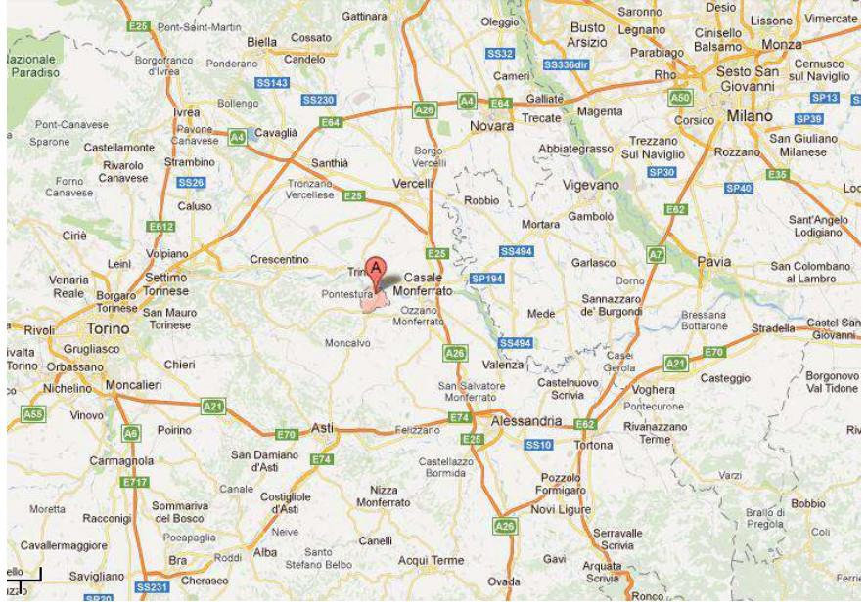

Pontestura has two “bars” and a restaurant (trattoria) located 300 meters from the school. Casale Monferrato, Moncalvo, Vignale and other typical Monferrato resorts are not far away. In addition, the season during which the Summer School is held is called the "party of the country" season with fairs taking place in the evening in many towns and villages.

**The nearest places to stay**:  
**B&B**  
Ozzano: “La corte delle quattro stagioni”. Tel. 0142.487094 348.2487203  
Rosignano: “I castagnoni” Tel. 0142.488404  
Mombello: “Palazzo Tornielli” Tel.392.7512347  
**AGRITOURISM**  
Pontestura: “Smeralda” Tel. 0142.466275 347.8497364  
Cereseto: “Tenuta Monvillone” Tel. 0142.940251; “Poggio degli Ulivi” Tel. 0142.940984/940482/940127  
S.Giorgio: “La Puledra” Tel 0142.806192  
Serralunga: “Tenuta Guazzaura” Tel. 0142.940289  
Moncalvo: “ La Quercia Rossa” Tel. 0141. 917535  
Camino: “Ca’ S. Sebastiano” Tel. 0142.945900/469595 339.5030545  
Gabiano – Varengo (Ostello): “ Ca’ Villa” Tel. 0142.945126